**DISASTER RECOVERY USING IBM CLOUD**

**TEAM MEMBERS:**

**A.VAISHALI**

**N.MOHANAPRIYA**

**S.SNEKA**

**V.POOJASRI**

**INTRODUCTION:**

* **Disaster recovery is the plan and processes for using the copies to quickly reestablish access to applications, data, and IT resources after an outage. That plan might involve switching over to a redundant set of servers and storage systems until your primary data center is functional again.**

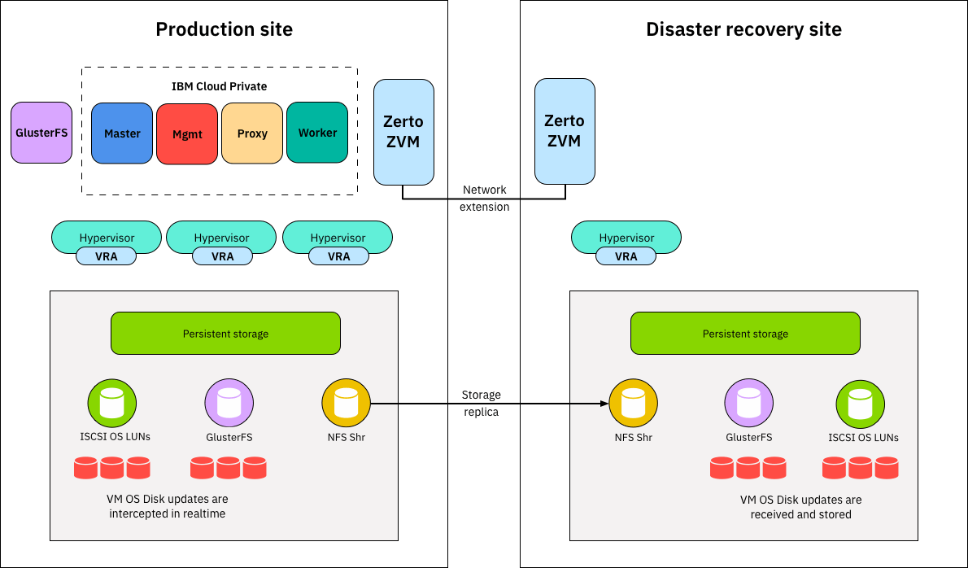

**DISASTER:**

A disaster is a serious problem occurring over a period of time that causes widespread human, material, economic or environmental loss which exceeds the ability of the affected community or society to cope using its own resources.

**DISASTER RECOVERY:**

Disaster recovery is the process of maintaining or reestablishing vital infrastructure and systems following a natural or human-induced disaster, such as a storm or battle. It employs policies, tools, and procedures.

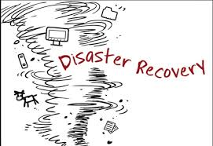

**RECOVERY STRATEGIES:**

* Your strategies should cover data backup and restoration, system and network redundancy, alternate site and equipment, communication and coordination, as well as roles and responsibilities. It is essential to test and update these strategies regularly to ensure their effectiveness and efficiency.
* Recovery Point Objective (RPO) and Recovery Time Objective (RTO) are two of the most important parameters of a disaster recovery or data protection plan. These are objectives that can guide enterprises to choose an optimal cloud backup and disaster recovery plan.

**BACKUP CONFIGURATION:**

* Configuration backup is a process of saving your existing network configuration files and creating a repository with all versions stored in incremental versions.
* Config backups are mostly encrypted before being stored in the database, to ensure high security.

**REPLICATION SETUP:**

* Cloud Replication refers to the process of replicating data from on-premises storage to the cloud, or from one cloud instance to another.
* Synchronous: The process of simultaneously saving data to both the primary and secondary storage platforms. ...
* Asynchronous: The process of saving data to the primary storage media first, then to the secondary storage media afterward.

**RECOVERY TESTING:**

* In software testing, recovery testing is the activity of testing how well an application is able to recover from crashes, hardware failures and other similar problems. Recovery testing is the forced failure of the software in a variety of ways to verify that recovery is properly performed.



**BUSINESS CONTINUITY:**

* Business continuity management is the process of planning for and dealing with potential threats and hazards to an organization's ability to maintain business continuity. This management requires: Evaluating the importance of different business functions in a business impact analysis.

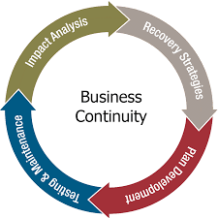

**THANK YOU**